Various sensors installed across the city

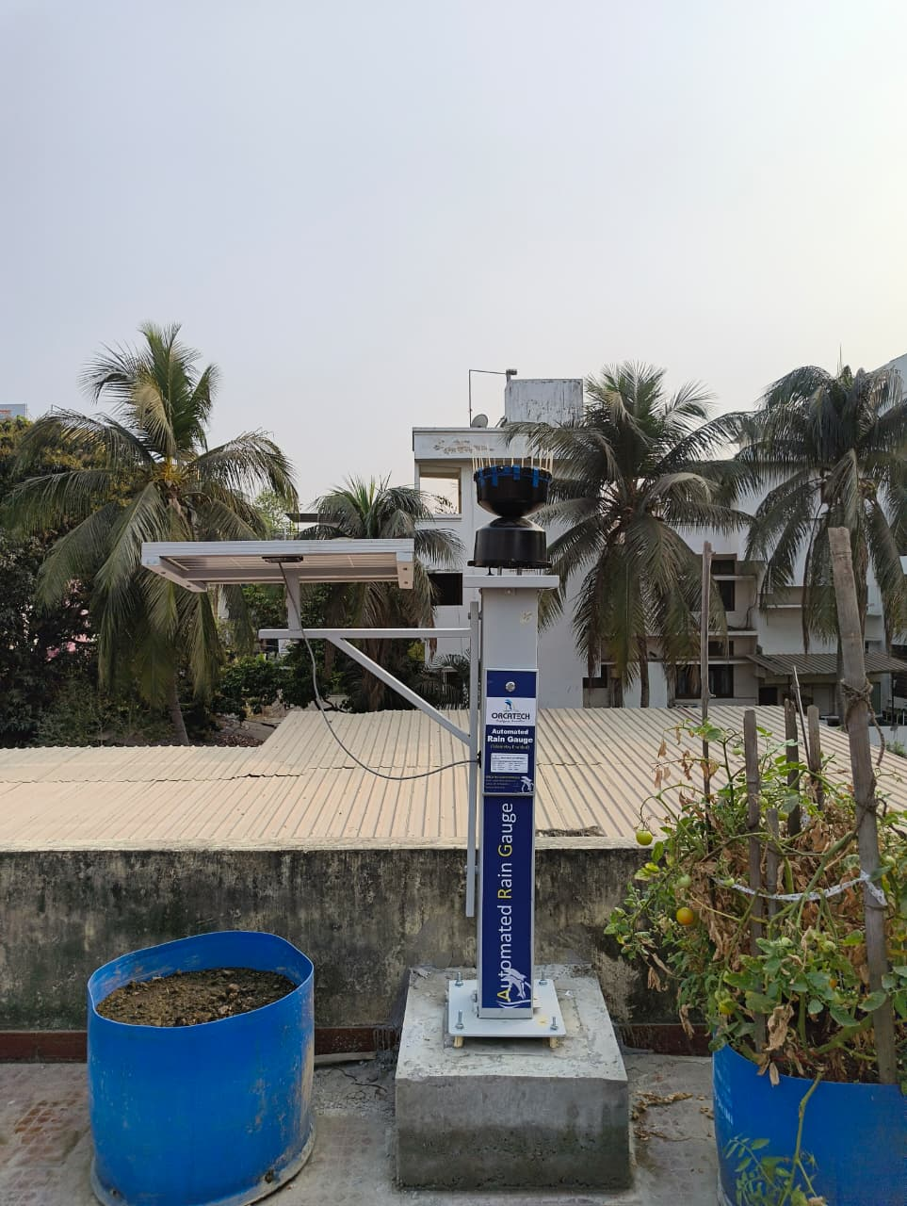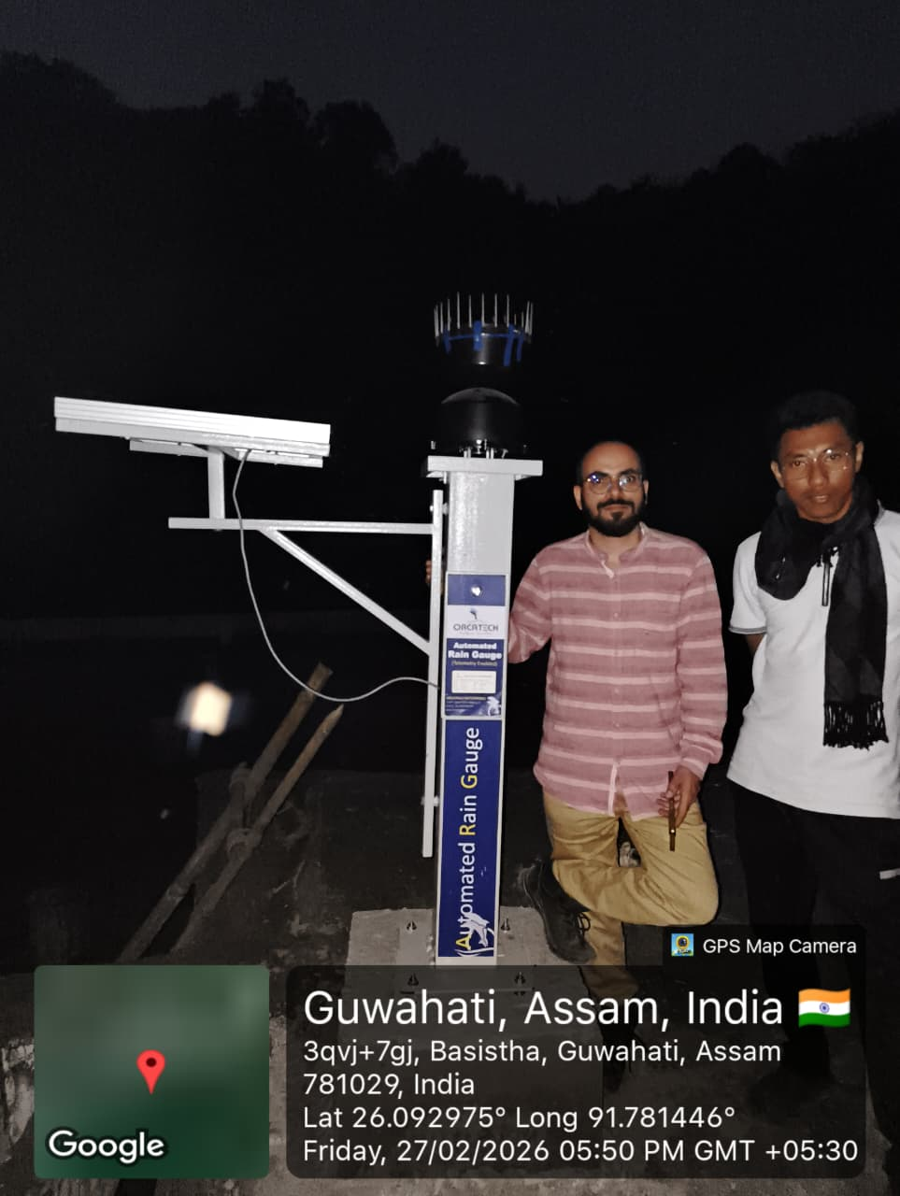
- Zoo Road- rain gauge 2) Basistha- Rain Gauge
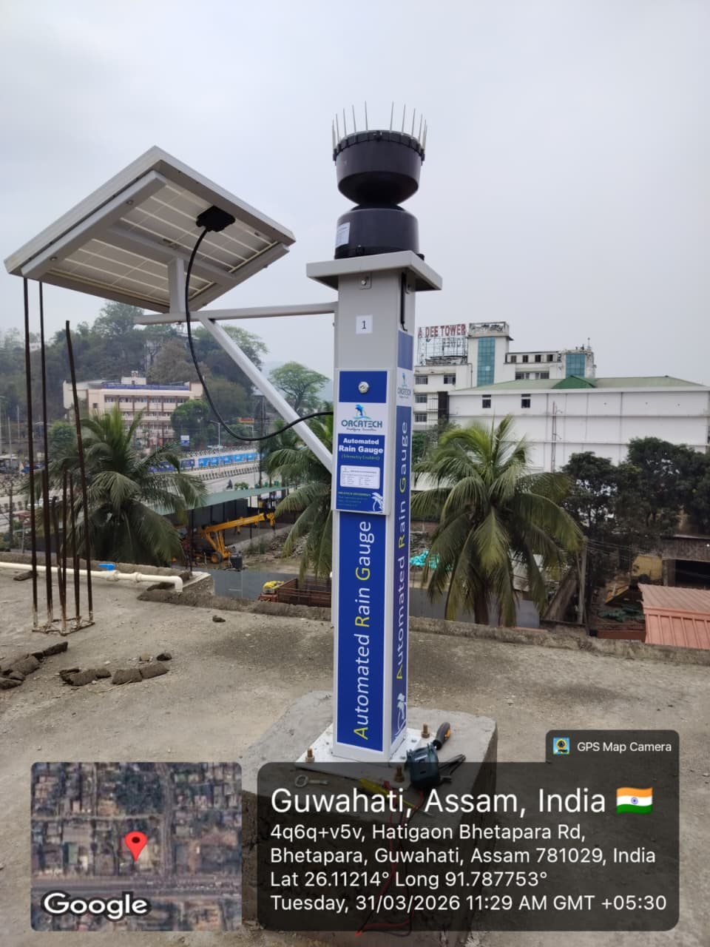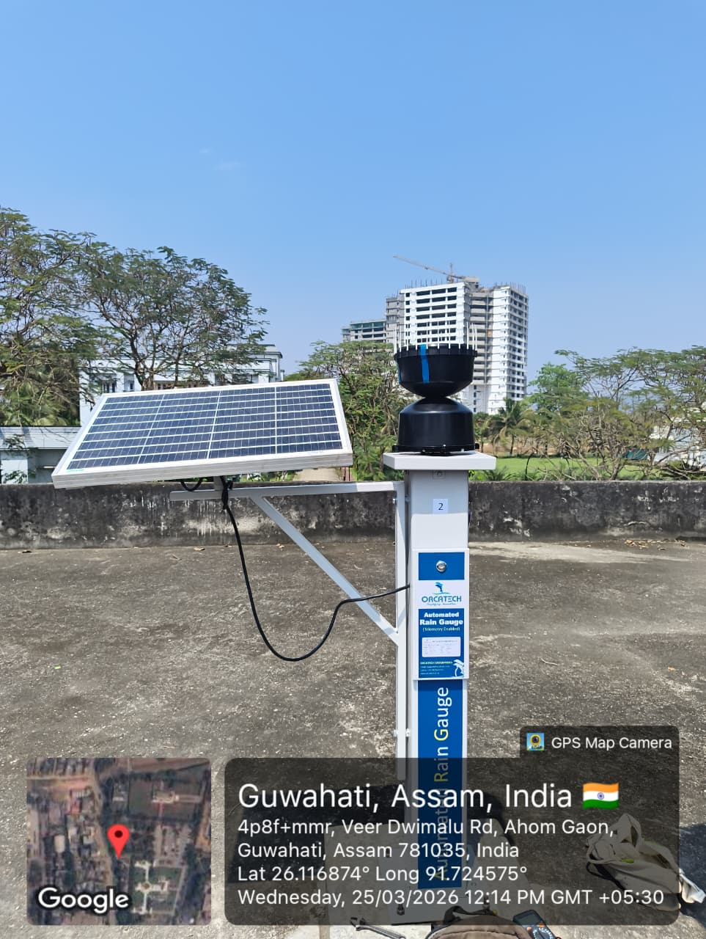
3) Bhetapara-Highway- Rain Gauge 4) Balaji Temple (Ahomgaon)- Highway

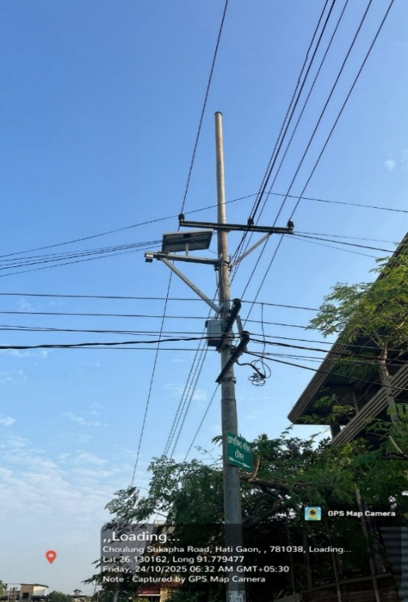
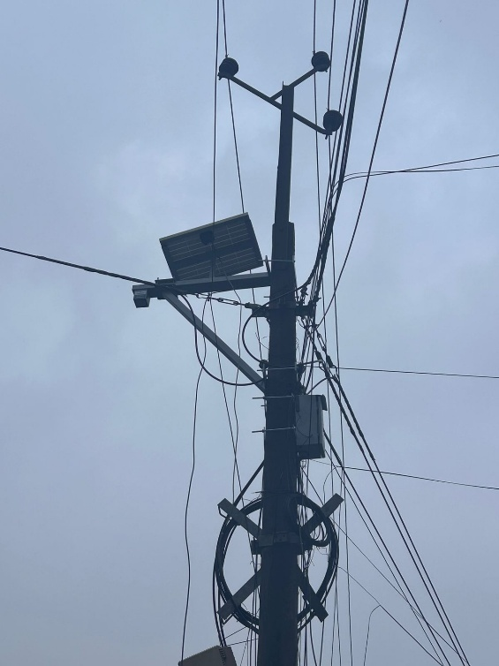
5) Zoo Road- Bharalu Water level sensor 6) Rukminigaon Water level sensor
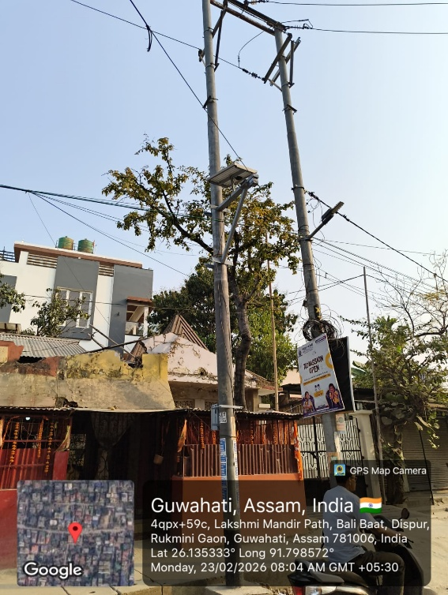
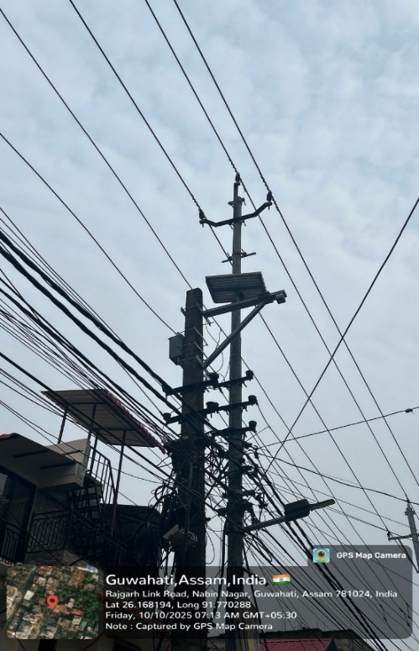
7) Nabin Nagar Water level sensor 8) Hatigaon Water Level Sensor

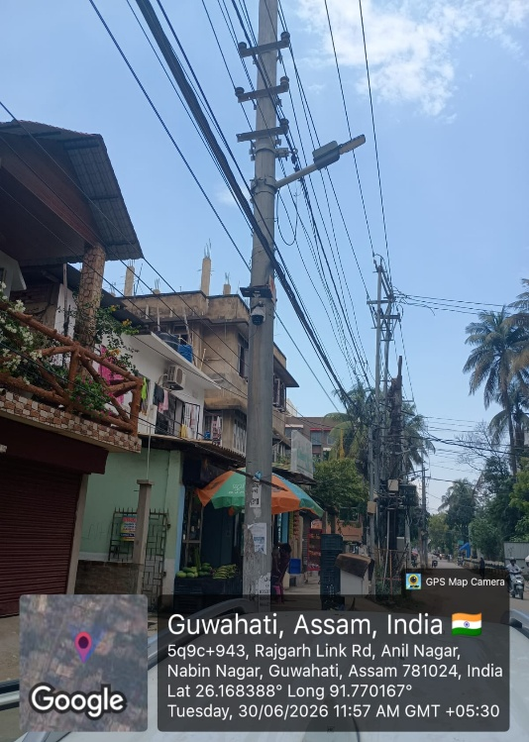
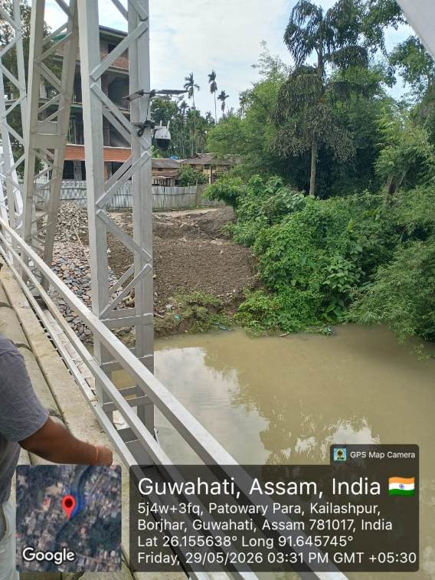

9) Kailashpur, Khanamukh CCTV 10) Nabin Nagar CCTV

